**(1) Merger of Princely States**

(not for prelims this is important for mains.)

Post independence of India:

1. Merger of princely states.
2. Refugee issue.
3. Democracy and the first general election.
4. Linguistic issue
   1. National language
   2. Linguistic reorganization of state.
5. Tribal integration.
6. Land reforms.
7. Communalism.
8. National integration.

Merger of princely states:

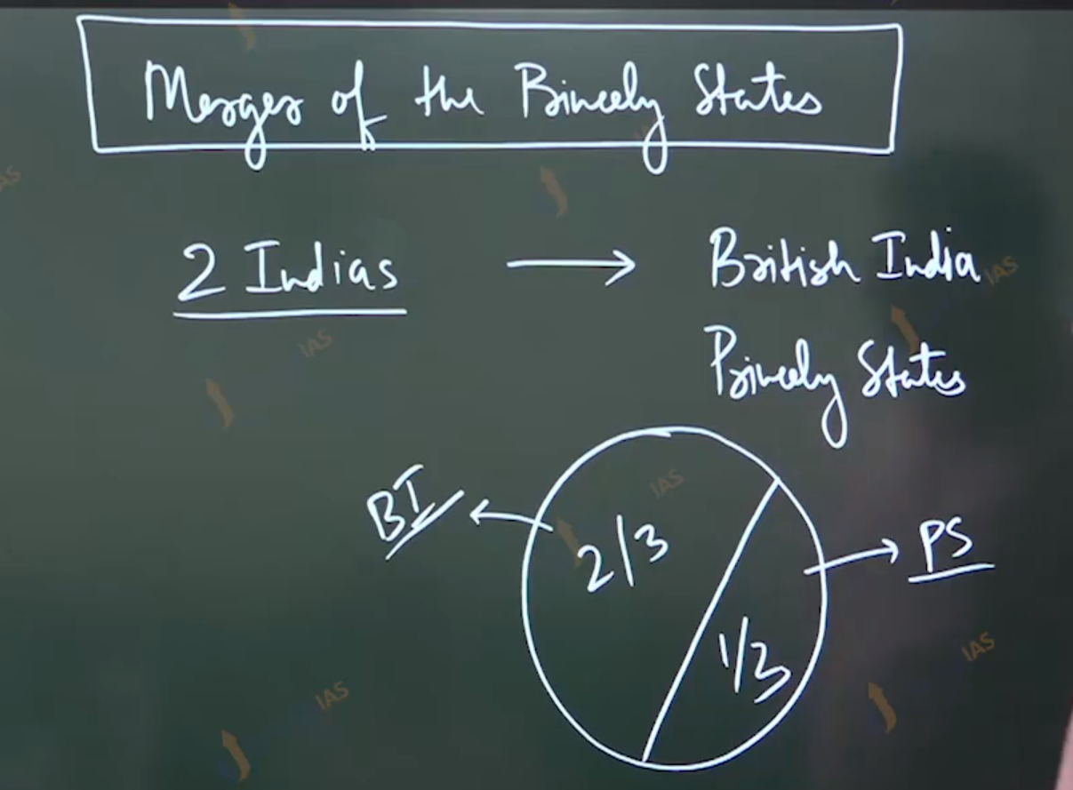

Since 1858:

1. Non annexation
2. Friendship
3. Co-operation
4. Defense

Reality PS :-

1. junior partner.
2. completely dependent upon the British.
3. British extracted the co-operation.
4. Administrative British subsides the princely state.

Indirect rule:

Mis- governance:

Challenge towards the intergradation of princely state

1. British portion
2. Recreation leader / ruler
3. Relatively low spread of political awareness and national
4. Issues arising out of partition.
5. Cold war block politics.

Roel of Patel and Menon and Mountbatten

State department

1. Minister: sardar Patel.
2. Secretory: vp Menon.

V.P Menon:

1. Approaches the diwans.
2. Instrument of accession. : which is legal document of formalities merger.